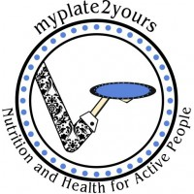
Fluffy Whole Grain Pancakes
MyPlate2Yours - Lynn Dugan

Makes 8

Ingredients
½ cup whole wheat flour
½ cup all-purpose flour
½ cup quick oats
¼ teaspoon salt
2 teaspoons baking powder
1 teaspoon ground cinnamon
1 large egg
1 cup milk
2 tablespoons brown sugar
¼ cup Greek yogurt
1 teaspoon vanilla extract

Directions
In a medium bowl, combine the first six ingredients (flours, oats, salt, baking powder, cinnamon) and make a well in center. Set aside.

In a separate bowl, combine egg and milk with a whisk. Whisk in brown sugar, yogurt and vanilla until well combined.

Pour wet ingredients into dry and stir gently until just combined. Heat large skillet or griddle over medium heat. If you are not using a non-stick pan, lightly coat pan with oil or butter. Drop ¼ cup batter for each pancake. Cook until the edges brown and bubbles form in center. Flip and continue cooking on other side, about 2 minutes. Continue until batter is used. Serve hot with maple syrup, fresh fruit and/or powdered sugar. Enjoy!

For fruity versions of this pancake, add a few washed blueberries to the batter just after it’s poured on the hot skillet. Or try sliced bananas, too. What fruit would you want to use? Try it and please let me know!

Recipe adapted from www.sallysbakingaddiction.com

